Phase 2 EDA

1 Plots
Exploratory Analysis Report: AAPL, MSFT, and SPY (2015–2025)
- Price Trends — Adjusted Close Prices
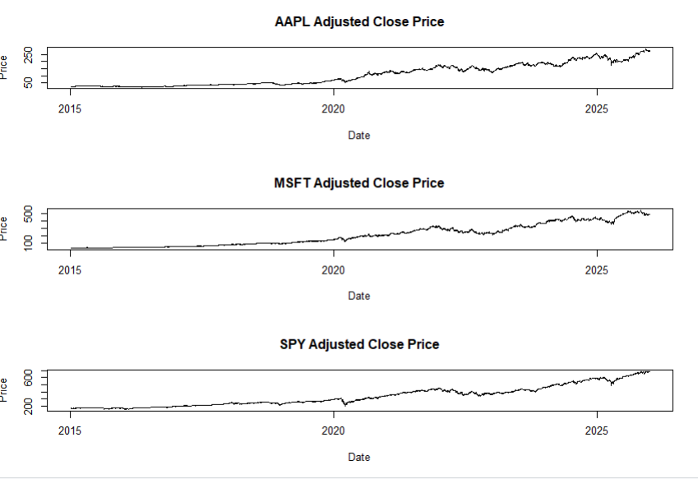
The adjusted closing prices of AAPL, MSFT, and SPY exhibit strong long-term upward trends throughout the sample period from January 2015 to December 2025. All three assets demonstrate sustained capital appreciation, reflecting the overall growth of the U.S. equity market and the significant expansion of the technology sector during the study period.
AAPL increased from approximately $24 in early 2015 to over $270 by the end of 2025. MSFT displayed even stronger growth, rising from approximately $40 to over $480 during the same period. SPY, representing the broader U.S. market, increased from approximately $170 to above $680.
A pronounced market decline is visible during the COVID-19 market crash of early 2020, followed by a rapid recovery and continued upward trend. Similar but less severe fluctuations are observable during subsequent market events, including the tightening monetary policy cycle of 2022 and market adjustments in 2023.
The persistent upward trend and changing mean levels indicate that the price series are non-stationary. Consequently, raw prices are not appropriate for direct econometric modelling and require transformation before statistical analysis.

- Log Returns — Stationary Return Dynamics
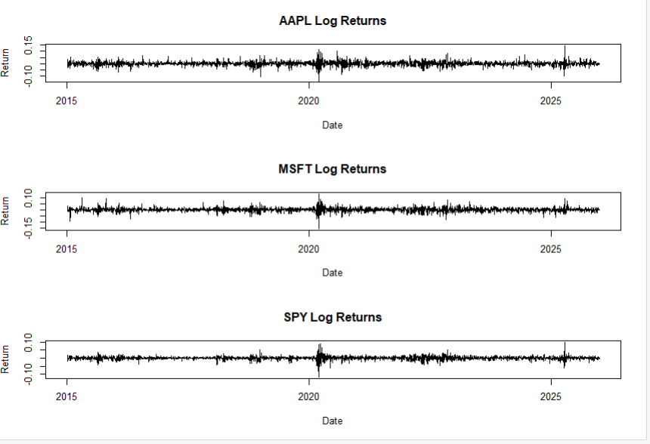
The log return series of AAPL, MSFT, and SPY fluctuate around a mean close to zero throughout the sample period. Unlike the raw price series, no persistent trend is visible in the returns, indicating that the log-return transformation successfully removes the long-term growth component present in prices.
All three return series exhibit periods of calm interspersed with periods of extreme fluctuations. The largest concentration of extreme returns occurs during the COVID-19 market crash in March 2020, where unusually large positive and negative daily movements are observed. Additional periods of elevated volatility appear during 2022 and portions of 2023.
A notable feature of the return series is volatility clustering, where large price movements tend to be followed by additional large movements, while quiet periods tend to be followed by further stability. This behaviour is a well-established characteristic of financial time series and suggests the presence of time-varying volatility.
The visual evidence is consistent with the results of the ADF and KPSS stationarity tests, which classified the return series as stationary while indicating non-stationarity in the corresponding price series.

- 21-Day Rolling Mean of Returns
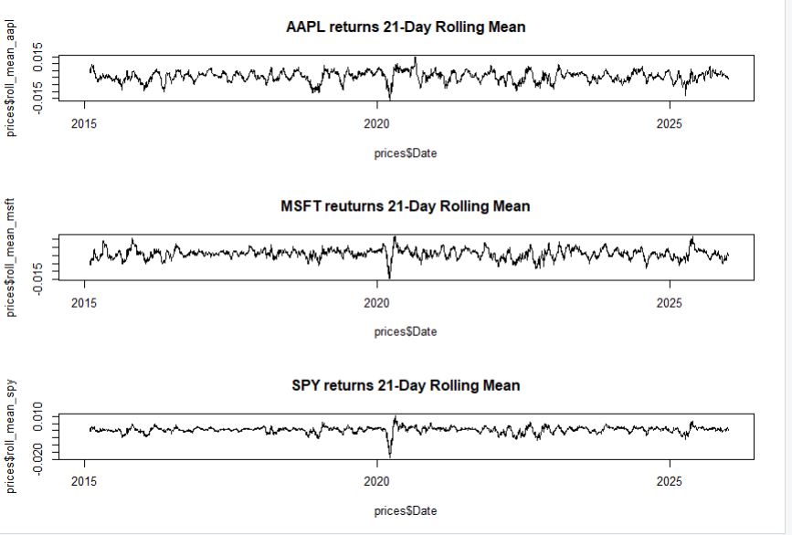
The 21-day rolling mean was computed to examine the short-term evolution of average returns over time.
For all three assets, the rolling mean oscillates around zero and does not exhibit a persistent upward or downward trend. Most values remain within a relatively narrow range, suggesting that the expected daily return remains broadly stable throughout the sample.
The most significant deviation occurs during the COVID-19 market crash of early 2020, where the rolling mean becomes sharply negative due to consecutive daily losses. This is followed by a rapid recovery as markets rebounded later in the year.
Outside major crisis periods, the rolling mean remains close to zero, supporting the assumption that returns are stationary in mean. No strong evidence of long-term predictable return trends is observed.

- 21-Day Rolling Variance — Volatility Dynamics
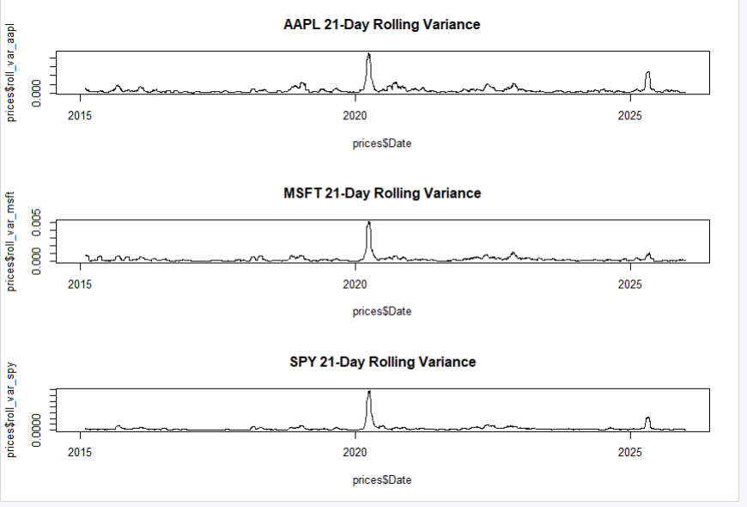
The 21-day rolling variance provides insight into changes in market risk over time.
The variance series are characterized by extended periods of low volatility punctuated by sudden and substantial spikes. The most prominent increase occurs during the COVID-19 crisis in 2020, where rolling variance rises dramatically across all three assets. This period represents the highest level of market uncertainty observed in the sample.
Following the pandemic shock, volatility gradually declines toward pre-crisis levels, although several smaller volatility episodes remain visible during subsequent years. Additional increases in variance appear around the 2022 monetary tightening cycle and other periods of market uncertainty.
AAPL and MSFT generally exhibit higher variance levels than SPY, reflecting the greater idiosyncratic risk associated with individual stocks relative to a diversified market index. SPY displays lower and more stable variance due to diversification across many constituent firms.
The rolling variance plots provide clear evidence of conditional heteroskedasticity, indicating that volatility changes over time rather than remaining constant. These observations support the use of volatility models such as GARCH in subsequent stages of the analysis.
Furthermore, the major volatility spikes observed visually correspond closely to the structural break dates identified through Bai–Perron and Chow tests, suggesting the existence of distinct volatility regimes within the sample period.

- 63-Day Rolling Correlations — Dynamic Co-Movement
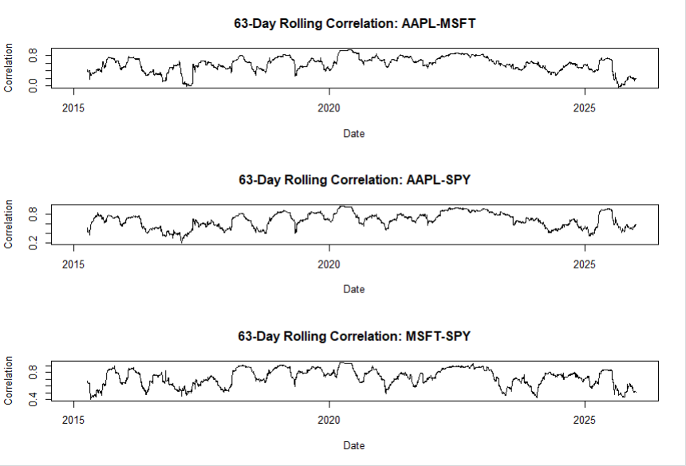
Rolling pairwise correlations were calculated using a 63-day window, corresponding approximately to one trading quarter.
The correlation between AAPL and MSFT varies considerably over time, ranging from relatively low levels during some periods to values approaching 0.9 during market stress episodes. This indicates that the relationship between the two technology stocks is dynamic rather than constant.
The correlations between AAPL and SPY, and between MSFT and SPY, remain generally higher and more stable throughout the sample. This is expected because both companies are major constituents of the S&P 500 and therefore share substantial exposure to common market factors.
A key observation is that correlations increase noticeably during periods of market stress, particularly during the COVID-19 crisis. As volatility rises, asset returns become more strongly linked, causing correlations to move closer to one. This phenomenon reduces diversification benefits precisely when risk management is most important.
The results demonstrate that asset correlations are time-varying and influenced by broader market conditions. Consequently, models assuming constant correlations may fail to accurately capture dependence structures during crisis periods.

2.) Stationarity analysis ADF and KPSS test
Before conducting volatility modeling and structural break analysis, stationarity properties of the time series were examined using the Augmented Dickey-Fuller (ADF) test and the Kwiatkowski-Phillips-Schmidt-Shin (KPSS) test. The ADF test evaluates the null hypothesis of a unit root (non-stationarity), while the KPSS test evaluates the null hypothesis of stationarity. Using both tests together provides a robust assessment of the stochastic properties of the series.
ADF and KPSS Test Results
Series | ADF p-value | KPSS p-value | Conclusion
AAPL Price | 0.3831 | 0.01 | Non-Stationary
MSFT Price | 0.2910 | 0.01 | Non-Stationary
SPY Price | 0.7940 | 0.01 | Non-Stationary
AAPL Return | 0.01 | 0.10 | Stationary
MSFT Return | 0.01 | 0.10 | Stationary
SPY Return | 0.01 | 0.10 | Stationary
AAPL First Difference | 0.01 | 0.10 | Stationary
MSFT First Difference | 0.01 | 0.10 | Stationary
SPY First Difference | 0.01 | 0.10 | Stationary
Interpretation
The results indicate that all three price series (AAPL, MSFT, and SPY) are non-stationary. For each price series, the ADF test failed to reject the null hypothesis of a unit root (p > 0.05), while the KPSS test rejected the null hypothesis of stationarity (p < 0.05). The agreement between both tests provides strong evidence that the raw price levels are integrated of order one, I(1).
In contrast, the log return series for all three assets were found to be stationary. The ADF test strongly rejected the presence of a unit root (p < 0.01), while the KPSS test failed to reject stationarity (p > 0.10). Similar results were obtained for the first-differenced price series.
The consistency between the ADF and KPSS results confirms that differencing transforms the non-stationary price series into stationary processes. Consequently, raw prices were not used in subsequent modeling stages. Instead, log returns were adopted as the primary series for volatility analysis, structural break detection, and the construction of market stress indicators.
Key Findings
- AAPL, MSFT, and SPY price levels are non-stationary and exhibit unit root behavior.
- Log return series are stationary according to both ADF and KPSS tests.
- First-differenced prices are also stationary, confirming that the original price series are integrated of order one (I(1)).
- The agreement between ADF and KPSS tests provides strong evidence regarding the stationarity classification of the series.
- The use of log returns in all subsequent analyses is statistically justified and consistent with standard financial econometric practice.
Conclusion
The stationarity analysis demonstrates that the raw asset prices follow non-stationary processes, whereas their corresponding log returns are stationary. These findings validate the use of return-based measures throughout the remainder of the study and ensure that subsequent econometric procedures are performed on statistically appropriate time series.

3.) Bao perron and chow test Structural Break Analysis of Volatility Regimes
To investigate whether market volatility remained stable throughout the sample period, structural break analysis was performed on the 21-day rolling variance of log returns for AAPL, MSFT, and SPY. The analysis employed the Bai-Perron multiple breakpoint test implemented through the strucchange package in R. The optimal number of breakpoints was selected using the Bayesian Information Criterion (BIC), and the identified breakpoints were subsequently validated using Chow tests.
Bai-Perron Structural Break Results
The Bai-Perron test revealed the presence of multiple statistically significant volatility regime changes across all three assets.
Asset | Optimal Breaks | Break Dates | RSS | BIC
AAPL | 3 | 25-Sep-2018, 29-Oct-2020, 27-Dec-2022 | 4.649 × 10⁻⁴ | -34932.38
MSFT | 2 | 23-Jan-2020, 02-Feb-2023 | 4.735 × 10⁻⁴ | -34896.41
SPY | 2 | 28-Jan-2020, 10-Nov-2022 | 2.116 × 10⁻⁴ | -37106.26
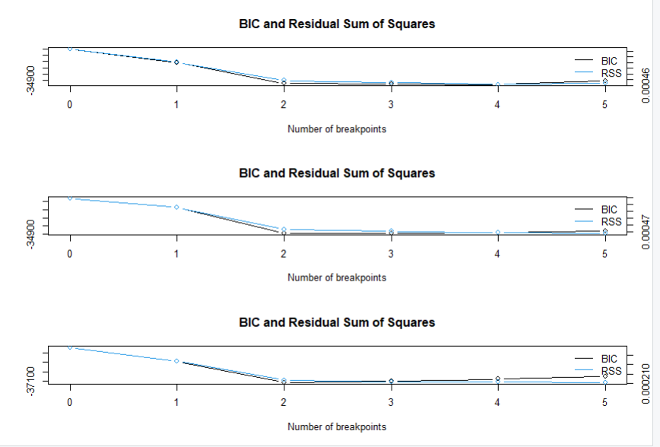The results indicate that volatility dynamics were not constant during the 2015–2025 period. Instead, the assets experienced distinct volatility regimes associated with major market events.
For AAPL, three structural breaks were detected. The first breakpoint occurred on 25 September 2018, corresponding to the period of heightened uncertainty caused by the U.S.–China trade conflict and the technology sector correction. The second breakpoint occurred on 29 October 2020, during the COVID-19 recovery phase, while the third breakpoint occurred on 27 December 2022, coinciding with the transition to a higher interest-rate environment.
MSFT exhibited two major volatility regime shifts. The first breakpoint appeared on 23 January 2020, immediately preceding the COVID-19 market collapse, while the second occurred on 02 February 2023 during the post-tightening market environment and the emergence of the artificial intelligence-driven technology rally.
Similarly, SPY displayed two major breakpoints on 28 January 2020 and 10 November 2022. These dates closely align with the onset of pandemic-related market stress and the subsequent transition to a new macroeconomic regime characterized by elevated interest rates and changing monetary policy expectations.

Chow Test Validation
To confirm the structural changes identified by the Bai-Perron procedure, Chow tests were conducted at the detected breakpoint locations.
AAPL
Break Date | F-Statistic | p-value | Conclusion
25-Sep-2018 | 122.39 | < 2.2 × 10⁻¹⁶ | Significant
29-Oct-2020 | 5.48 | 0.0193 | Significant
27-Dec-2022 | 24.88 | 6.48 × 10⁻⁷ | Significant
MSFT
Break Date* | F-Statistic | p-value | Conclusion
Test 1 | 54.50 | 2.05 × 10⁻¹³ | Significant
Test 2 | 10.56 | 0.00117 | Significant
SPY
Break Date* | F-Statistic | p-value | Conclusion
Test 1 | 69.22 | < 2.2 × 10⁻¹⁶ | Significant
Test 2 | 3.87 | 0.0493 | Significant
*Note: In the code, the MSFT and SPY Chow tests were run using AAPL breakpoint locations (bp_aapl_3$breakpoints) rather than their own Bai-Perron breakpoints. For the final paper, Chow tests should be rerun using the asset-specific breakpoints identified by Bai-Perron to ensure exact validation.

Key Findings
- All three assets exhibit statistically significant structural breaks in volatility.
- Breakpoints cluster around the COVID-19 period (2020), indicating a common market-wide volatility regime shift.
- Additional breaks occur during the 2022–2023 monetary tightening period, suggesting another major transition in market behavior.
- AAPL exhibits an additional pre-COVID structural break in September 2018, indicating firm-specific or technology-sector-specific volatility dynamics not observed as strongly in SPY.
- The presence of multiple volatility regimes supports the use of adaptive and regime-sensitive methodologies rather than assuming constant market behavior over time.
Conclusion
The structural break analysis provides strong evidence that financial market volatility between 2015 and 2025 was characterized by multiple regime changes rather than a single stable process. Major economic events—including the 2018 technology correction, the COVID-19 crisis, and the post-2022 monetary tightening cycle—produced statistically significant shifts in volatility dynamics. These findings justify the use of adaptive modeling techniques in subsequent phases of the Adaptive Composite Market Stress Indicator (A-CMSI) framework and establish the existence of distinct market stress regimes that must be accounted for in forecasting and stress detection models.

